CS8803-AI for Robotics Final Project Report
Matthew Houston mhouston@gatech.edu
Conor Livingston conorliv@gatech.edu
Zhi Zhang zhizhang@gatech.edu

In this report, we will describe the approaches we took to finish our prediction:
The first step we did is to watch the video and look at the data to get the basic idea about the problem.
We made a map of the robot’s path using the training data. In the figure below the hexbug's path has been drawn as a green line. We have training data for almost every point in the box.
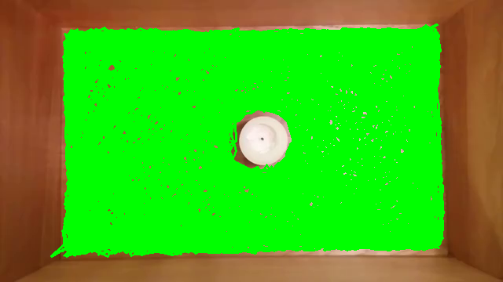

We probably do not have training data for every possible combination of 5 frames so whatever predictor we generate will have to generalize.
We then generated a heat map of robot location to see how often is it in each location. Below is what we got:
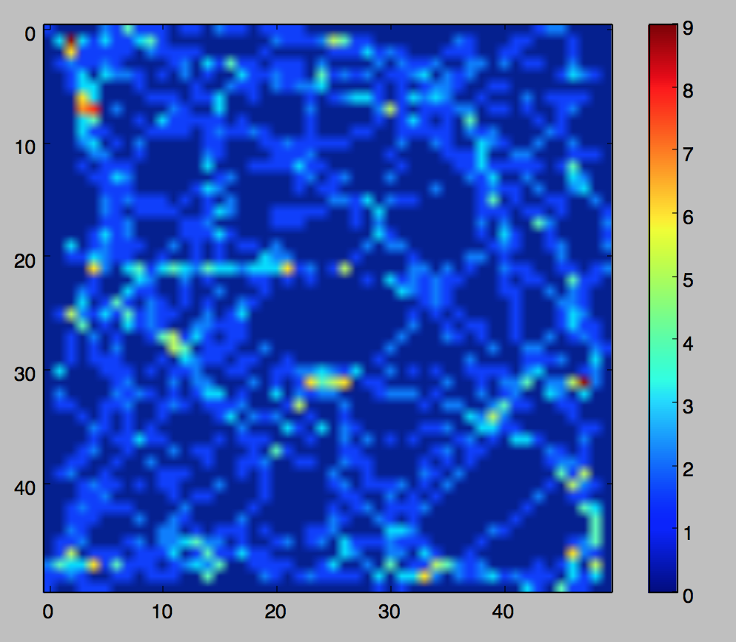

We also observed the hexbug motion by calculating some statistics on the training data.
The average magnitude of the hexbug velocity is 6.57. The histogram of robot velocities is as below:
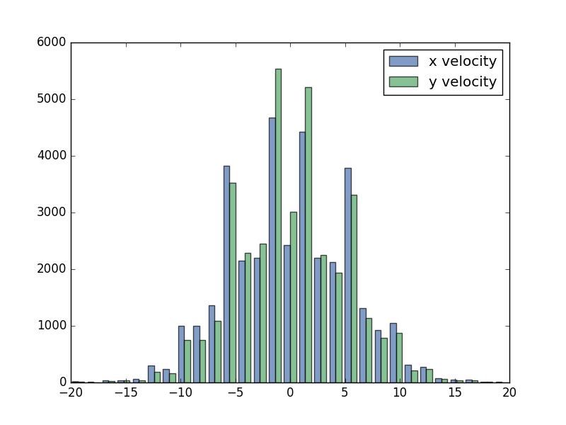
The Bayesian comparison of the robot's distance from a given point and the robot's distance from that point given it was near that point 60 frames ago:
By watching the video, there are three types of robot behavior we observed. 1. In free space, the robot moves in arcs. These seem easy to predict and the neural network predictor does a good job on them. At flat obstacles the robot tends to reflect off the obstacle, but not perfectly. The neural network predictor captures some of these instances. Finally, the robot sometimes gets stuck in a corner, bounces for a bit, then eventually escapes. This looks almost like a chaotic problem
After observation and familiar with the data, we thought the machine learning algorithms could be a potential method to utilize, so we applied several machine learning techniques to the training data.
We choose three common machine learning classifiers, K Nearest Neighbors, Random Forest Regression, and Simple Neural Network. Each of the following regressions was trained to predict the next 60 robot locations using the past 5 locations as an input. We used the first 30,000 frames of the 20 minute video as training data and the last 4750 frames as validation data, below is the performace of these algorithms on the training data:
Current Location Validation MSE = 31792
K Nearest Neighbors Validation MSE = 5693
Random Forest Regression Validation MSE = 5617
Simple Neural Network Validation MSE = 4700

Note "Current Location" just guesses the current location of the robot as its position for the next 60 frames.
From the result we can see that most machine learning algorithms are producing errors that range from 4,700 to 6,500.
For each of these predictors, we made a video illustrating the behavior in action.
Below are the youtube video links of our predictors:
https://youtu.be/SGovl2a8KQQ
https://youtu.be/etMk4PFJ0iw
https://youtu.be/Rk8e02DwCP8

It is clear that these algorithms are able to pick up on some of the structure in the problem but also aren't capturing all of it. And none of the learners is great at predicting when the robot will leave the corner once it is stuck. We've spent a lot of time looking at the model predictions and generally, they pick up on the shape of the motion, but fail to capture some of the nuance. For example most of the algorithms don't do a good job predicting how long the robot will remain stuck in a corner. The simple neural network shows promise. Unlike the other methodologies it seems to learn some of the physics behind the motion and produces stable predictions that don't change suddenly as the robot moves.
We also tried averaging the output from several simple models and got results that weren't much better than any individual model.
We then thought of some more complex algorithm, so we experimented with two more-complex neural network architectures and got results that were either worse or similar to the results from the simple machine learning algorithms. The architectures we experimented with were a GRU network (https://keras.io/layers/recurrent/#gru) and a variation on a residual network (https://arxiv.org/abs/1512.03385). The GRU network never reached a MSE less than 10,000 and the residual network achieved a MSE of 4,936.
Then we thought of making better training data. Our current training data contains only (row, col) coordinates. We then made a file with the following features - x position, y position, x velocity, y velocity and we then tried to build better feature vectors – using velocity as an input.
After input velocity, the accuracy of the ML algorithms is improved. The data below shows how helpful it can be to provide more data to the algorithms.

Neural Network:
 | Without XY Velocity | With XY Velocity | % Improvement
Median MSE | 4139 | 3834 | 7.369
Mean MSE | 5454 | 5312 | 2.604
Max MSE | 32602 | 35645 | N/A
Min MSE | 350 | 227 | 35.143

K-Nearest Neighbors:
 | Without XY Velocity | With XY Velocity | % Improvement
Median MSE | 3896
Mean MSE | 6325
Max MSE | 60784
Min MSE | 26

Gradient Boosting Example:
 | Without XY Velocity | With XY Velocity | % Improvement
Median MSE | 4130
Mean MSE | 5285
Max MSE | 39165
Min MSE | 167

K-Nearest Neighbors had the most consistent accuracy improvements in all four MSE measurements that we’re paying attention to. Gradient Boosting had very strong improvements in median MSE and mean MSE, but somewhat weaker improvements in max and min MSE. However, it should be noted that Gradient Boosting still has a lower max MSE than K-Nearest Neighbors. One other observation is that the neural network had the lowest max MSE by quite a bit.
Based on these observations, we decided to enhance our data in all the ways we can think of.
We originally thought of incorporate the robot orientation as an input, but finally decided not to include due to its hard to implement based on the enormous data we can generate from the video frames.
We also thought of optimizing the hyper-parameters of our model, so we used the method of searching to decide the parameters. Below is the summary of performance of our algorithms after optimization of hyper-parameters:

The hyper-parameters improved the MSE of model performance.
Then we are interested into how the reconstruction of our input data by using the image processing. We used principle component analysis to represent a grayscale 50x50 pixel window around the robot as a 20 element vector. This is shown in the video here (https://youtu.be/GOVqE5taE5o). The original frame is on the left and the reconstructed frame is on the right.
The performance of residual neural network with all the data including the training data is slightly worse than the training data only, which is shown below:
We are curious about this irregular result, so we checked each data, and we found out that toward the end of the video test07.mp4, the robot falls onto its side and does not move for the rest of the video. This type of behavior wasn’t observed in all the other videos.
We excluded the test07.txt from our inputs and we retested the algorithms again, the performance of residual neural network got improved after this change. Below is the result:

Below are the strategies we proposed and haven’t tried:

1) trying to training short range predictors (2 steps ahead instead of 5) that iterate and comparing the results.
2) 100 pixel values from a 10x10 window centered on the robot
3) Take a look at XGBoost which appears to be winning a lot of Kaggle competitions
3) Dive into the literature to see if there's something obvious we're missing.
4) Carefully consider the cases in which the current algorithms fail and try to understand them.
5) Try to make a physics based model and see how that performs (e.g. the robot just reflects when it hits a wall)
6) nice to know how other teams are doing to understand if we are missing something obvious. sharing some sample results (e.g. our scores predicting frames 31000-31059 and 32000-32059) and asking other teams to do the same

Useful papers and blogs for write the report
Dropout: A Simple Way to Prevent Neural Networks from Overfitting
http://jmlr.org/papers/v15/srivastava14a.html
Batch Normalization: Accelerating Deep Network Training by Reducing Internal Covariate Shift
https://arxiv.org/abs/1502.03167
Ensemble Selection from Libraries of Models
https://www.cs.cornell.edu/~caruana/ctp/ct.papers/caruana.icml04.icdm06long.pdf
Want to Win Competitions? Pay Attention to Your Ensembles.
http://www.datasciencecentral.com/profiles/blogs/want-to-win-at-kaggle-pay-attention-to-your-ensembles

XGBoost: A Scalable Tree Boosting System
https://arxiv.org/pdf/1603.02754v1.pdf

XGBoost without tuning gives results which are slightly worse than the neural network based approaches (~5,300), but it is much faster to train (minutes vs hours).

